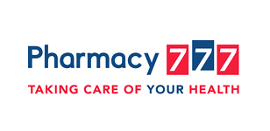

FREE Community Event
Movie Night Under the Stars “Inside Out”
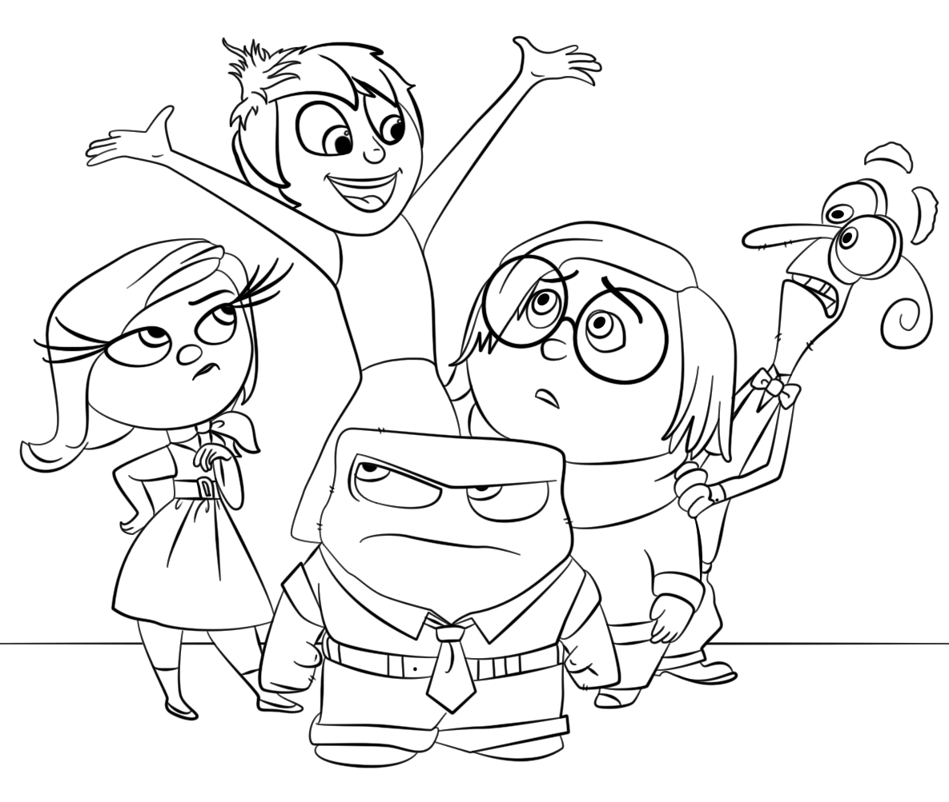
Celebrate Mental Health Week

Full Name: ________________________________ Age: ___________
Please Submit your colour-in for our competition instore at Pharmacy 777 Nollamara before Friday 14th October.
Winners will be announced and receive prizes at our ‘Movie Night Under the Stars’ FREE Community Event for Mental Health Week.
Event Details: Friday 14th October 6.00pm-8.30pm. Venue: Pharmacy 777 Nollamara. Popcorn provided FREE. Movie shown is “Inside Out”.

